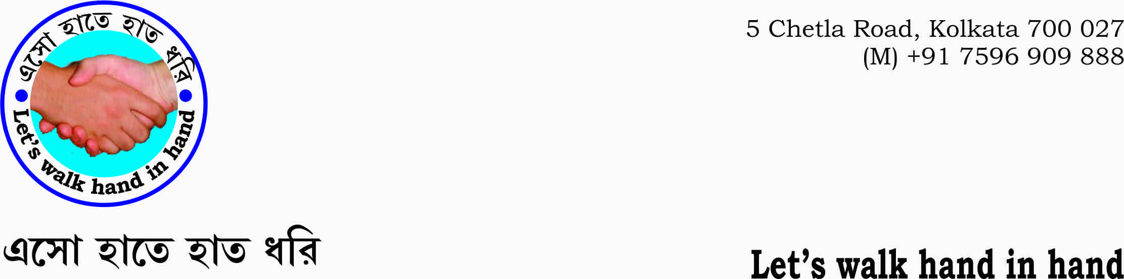
Minutes of the meeting held on 26 Dec.’17 at 4.30 PM at P-78, Lake Road, Kolkata-29.
President of the meeting: Mr. P.C. Sen & Convener: Kalyan Bhattacharya
Special Invitees: Mr. Goutam De, Regional Secretary, ICCR; Shibaprasad Basu ; Ms.Juthika Pal, Mr. Somnath Pyne, Mr. Majumder.
Members: Mrs. Dwipanwita Basu, Mrs. Shyamali Rakshit, Mrs. Madhusree , Mrs. Mita Bose,Mr. Gopi Kanta Ghosh, Mr. Amalesh Dasgupta, Mr. Hemendu Bikash Chowdhury.

Proceedings:
Upon the advice of the President, Kalyan read out the subject of the meeting which is briefed as follows:
1. Unless we have a culture of respect and cooperation among all the sections of the people nothing could be done. We need to bring about a Culture. This appears to be the need of the hour today. Culture creates a ‘system or discipline’ which in turn builds a nation.
In order to achieve it we have decided to perform the following activities all throughout the country.
- Cultural programmes, such as, drama, films, documentaries of great men and explaining in a very simple and easy manner the relevant poems and literature of the great men.
- Organizing discussions and debates on topical relevant issues by inviting the stakeholders.
- Initiate to write essays and short stories at all levels right from the children’s in Schools, Colleges, and Universities and from the general public on relevant topics in the competition.

2. President, Mr. P.C.Sen expressed his view. He said that something needs to be associated with this so that the concerned people could earn their livelihood while learn about the necessity of creating culture, because, he said unless they could feed themselves attempt to create culture would not be possible. He gave an example, how people in the villages do business with generating and collecting honey.
3. Mr. Gautam De told that some sort of work has to be associated with the or

4. Mr. Gopi Kanta Ghosh told about his various social welfare attachments. He said that the artisans in different fields are quite adept in their fields and then why not they be awarded the formal certificates or degree in their respective fields? He also told that now initiative has been taken by authorities to award formal academic certificates to the right men
He also told that he is associated with some activities in the villages in the south 24 parganas.

Conclusion:
- Mrs. Krishna Sen stressed upon discipline. She said discipline is the basic need for doing anything. It is of utmost importance.
Other than Mrs. Krishna Sen all spoke about their notion about Culture in general and stressed the need for creating livelihood for the toiling people without which they said it is difficult to achieve the desired result. The hungry people need food first for their very survival and then they go for other necessities.
- But it is to be noted that none other than Mrs. Krishna Sen discussed about the subject of creating culture through various programmes as mentioned in the briefing read out by the convener Kalyan Bhattacharya.

- As it was the first formal meeting of the organization, it was thought that the exchange of views of all the members and the special invitees was nonetheless necessary. It is assumed that the members would focus upon the objectives and the agenda from the next meeting onward.

